08
Fall
Shannons Adelaide Rally 2022

Stage Detail for Adelaide Hills / Fleurieu Stages
TBC
V4 29/3/22

Promoted Community Event

Saturday 26th November 10am to 3pm TBC

Uraidla Oval
Cars to be parked on showgrounds space and Uraidla School oval.
Spectators to access the area via thoroughfare from Uraidla Main street and Hotel.
Band located at Hotel.

Road Closed:
None

Traffic Management
Possible 40kph zone along Swamp Rd and Greenhill Rd

Prima Tour lunch event

Thursday 24th November

Deviation Rd Winery – Scott Creek Rd

Road Closed:
None

Traffic Management
None – Existing Closed Road Stage

SS1 - Bradbury

Road Closed:
Mount Bold Road
Dorset Vale Rd

Closure Start:
Cnr Gurr Rd and Bold Rd

Closure Finish:
Dorset Vale Rd adjacent Scott Creek Conservation Park boundary

Intersections along Stage:
None

Operational: Keep Existing RSP, FF and SP same as 2021

THURSDAY 24th 7:25am to 11:20am TBC
https://www.google.com/maps/dir/-35.0827988,138.7025782/-35.0980029,138.6841381/@-35.0907856,138.6861375,14.25z/data=!4m2!4m1!3e0

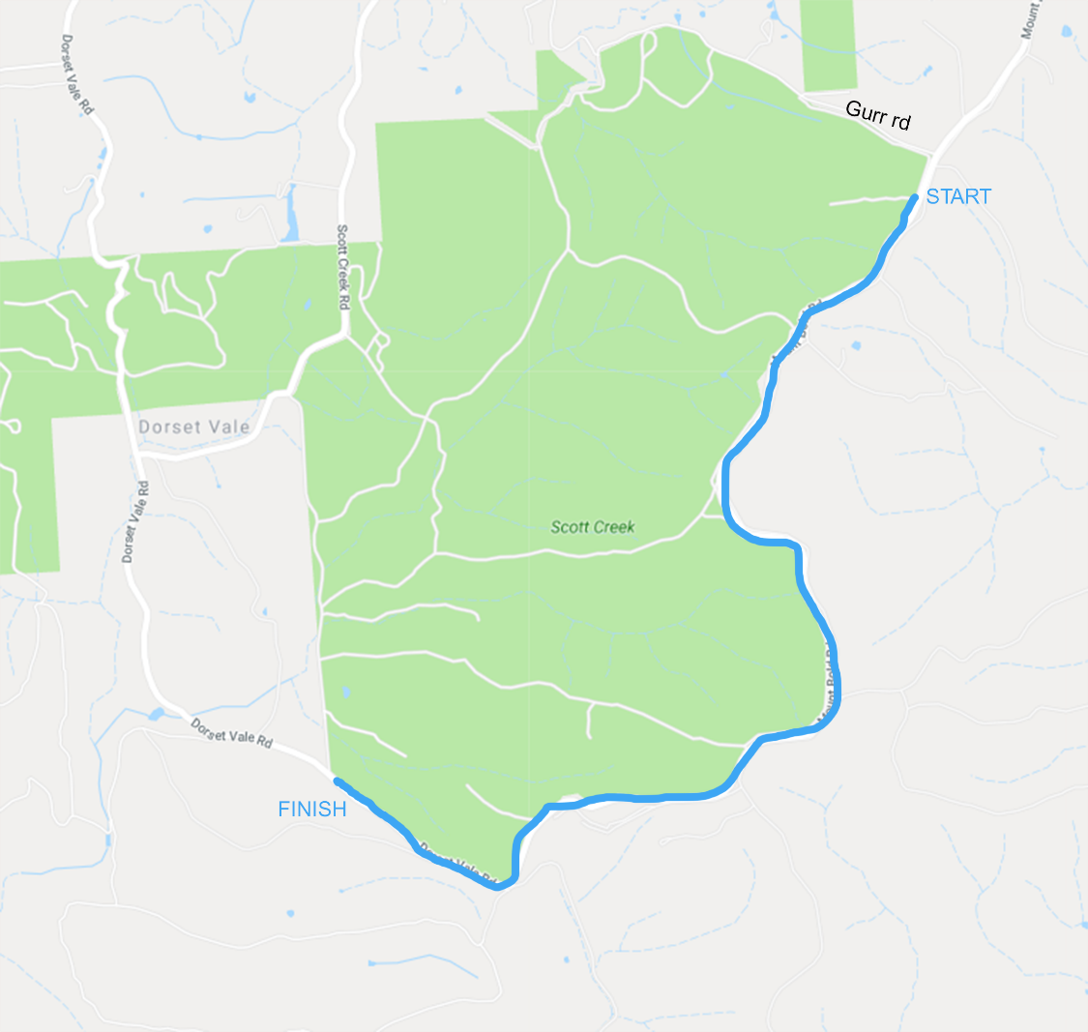

SS2 - The Mineshaft

Road Closed:
Dorset Vale Rd

Closure Start:
Mathews Rd and Dorset Vale Rd

Stage Start : Cnr Mineshaft Track and Dorset Vale Rd
Closure Finish:
Cnr Frith Rd and Dorset Vale Rd

Intersections along Stage:
None

Operational: TS at bitumen FF @149 Dorset Vale Rd, SP at Frith Rd

THURSDAY 24th 7:45am till 11:25am TBC
https://www.google.com/maps/dir/-35.086572,138.675323/-35.0737683,138.6726037/@-35.0802732,138.661635,15.21z/data=!4m2!4m1!3e0

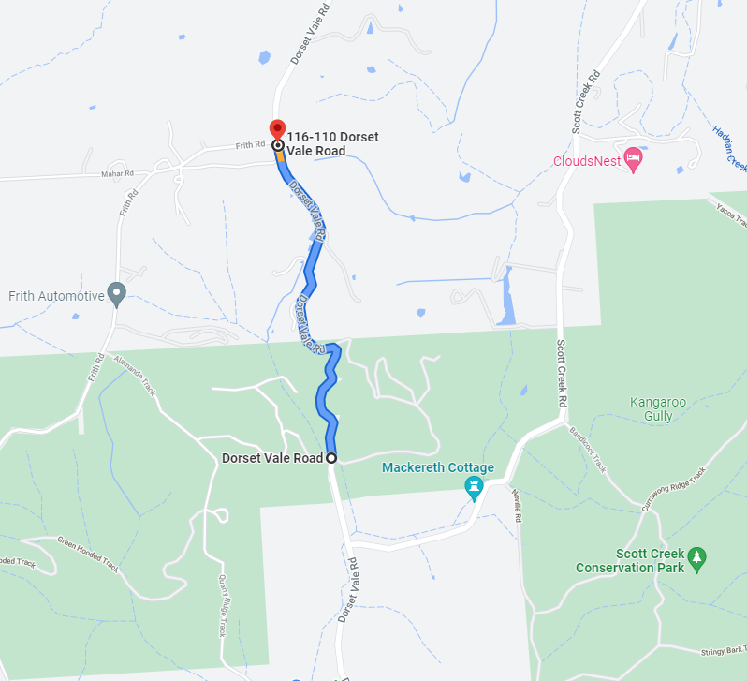

SS3 - Badenochs 1

Road Closed:
Greenhill Rd
Badenochs Rd

Closure Start: Cnr Beaumonts and Greenhill Rds
Stage Start: 200m in from Beaumonts Rd

Closure Finish: Cnr Carey Gully Rd and Badenochs Rd

Intersections along Stage:
Ostigh Rd
Tanamerah Rd

Operational: RSP @ 4.25km, !!C @ 3.76 and 4.5 Arrow signage needed at 3.76, FF @ 34°58.483'S, 138°45.645'E

THURSDAY 24th 8:30am till 1:55pm TBC
https://www.google.com/maps/dir/-34.9848905,138.7953898/-34.9746446,138.7570255/@-34.9762943,138.7642785,14.5z/data=!4m2!4m1!3e0

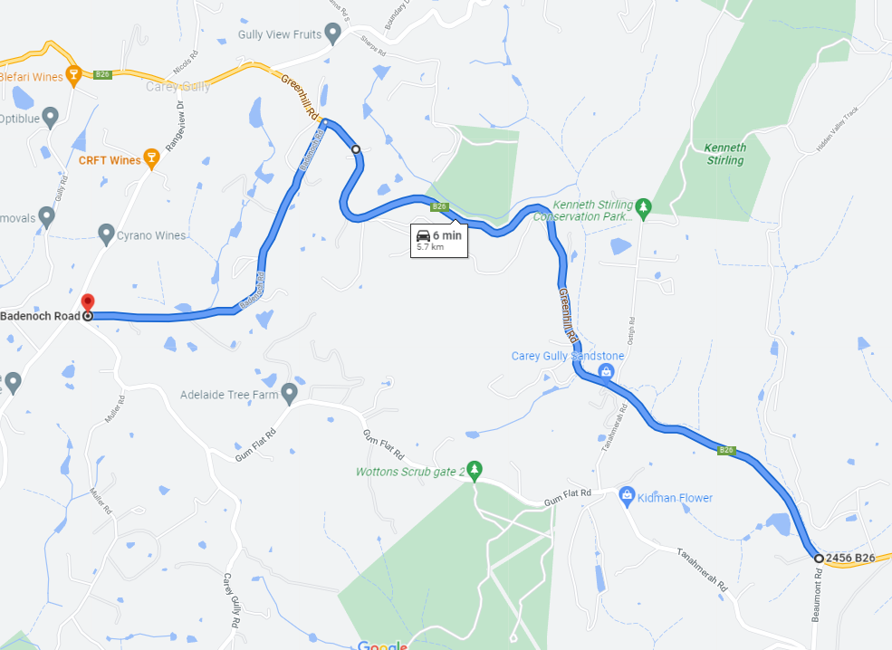

SS4 - Knotts Hill

Road Closed:
Hunters Rd
Knotts Hill Rd

Closure Start: 80m down Hunters Rd from Lobethal Rd (IMPORTANT..ACCESS REQUIRED for house on corner of HUNTERS RD/LOBETHAL RD..driveway is about 80m down Hunters on RHS )
Stage Start: 200m in from Hunters Rd/ Lobethal Rd intersection
Closure Finish: Pound Rd and Marble Hill Rd Intersection

Intersections along Stage:
Knotts Hill Rd
Blockers Rd
Raymonds Rd
Osborne Rd
Whightmans Rr

Operational: Same as 2021 RSP @ .85

THURSDAY 24th 8:20am till 12:15pm
https://www.google.com/maps/dir/-34.9373441,138.7704527/-34.9317026,138.745715/@-34.9336188,138.7584397,15z/data=!4m2!4m1!3e0

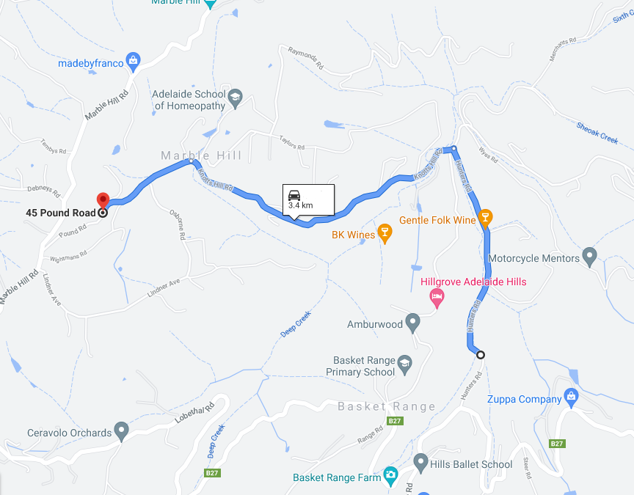

SS5 - Morialta 1

Road Closed:
Montacute Rd, Corkscrew Rd, Gorge Rd,

Closure Start:
Maryvale Rd / Montacute Rd intersection
Stage Start : 100m East of Black Hill Cons Park Entrance

Closure Finish:
Prairie Rd /Gorge Rd

Intersections along Stage:
Smiths Gully Rd
Institute Rd
Church Rd
Valley Rd
Gorge Rd
Batchelor Rd
Corkscrew Rd
Smiths Gully Rd
Institute Rd
Trebilcock Rd
Church Rd

Operational: Same TS and FF, same RSP as Cherryville. Place water barriers at bottom of Corkscrew Road along river edge.
THURSDAY 24th NOVEMBER 9:10am to 3:30pm TBC
https://www.google.com/maps/dir/-34.8854315,138.7051199/-34.8402495,138.8091468/@-34.8655552,138.7456006,13.5z/data=!4m9!4m8!1m5!3m4!1m2!1d138.747008!2d-34.8842485!3s0x6ab74aecfdc540d3:0x1948f9473e62b65a!1m0!3e0
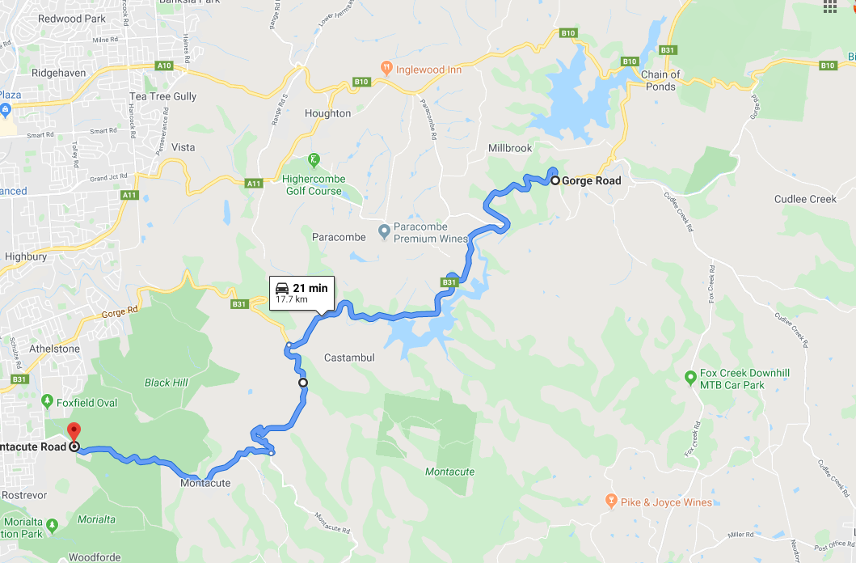

SS6 - Stafford Hillclimb 1

Road Closed:
Fox Creek Rd
Mawson Trail
Staffords Rd

Closure Start:
Adjacent Fox Creek Mountain Bike Park Carpark - Fox Creek Rd
Stage Start : As close to Mtn Bike Park carpark as possible.
Closure Finish:
Staffords Rd approximately 150m from Mawson Trail

Intersections along Stage:
Croft Rd, Coldstore Rd

Operational: Same as 2021 RSP @ .7. Bike Park to remain open.

THURSDAY 24th NOVEMBER 9:45am to 1:45pm
https://www.google.com/maps/dir/-34.8774356,138.8387514/-34.8942201,138.8404196/@-34.8870647,138.8341013,15.25z/data=!4m2!4m1!3e0

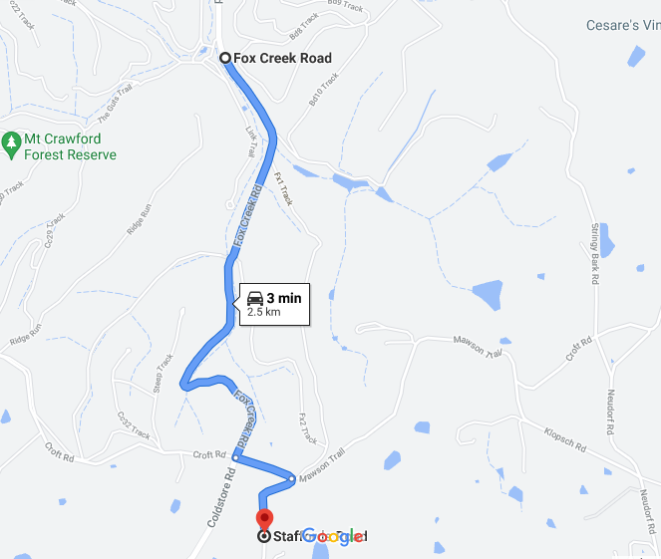

SS7 - Badenochs 2

Road Closed:
Greenhill Rd
Badenochs Rd

Closure Start: Cnr Beaumonts and Greenhill Rds
Stage Start: 200m in from Beaumonts Rd

Closure Finish: Cnr Carey Gully Rd and Badenochs Rd

Intersections along Stage:
Ostigh Rd
Tanamerah Rd

Operational: Same as Badenochs 1

THURSDAY 24th 8:30am till 1:55pm TBC
https://www.google.com/maps/dir/-34.9848905,138.7953898/-34.9746446,138.7570255/@-34.9762943,138.7642785,14.5z/data=!4m2!4m1!3e0

SS8 - Morialta 2

Road Closed:
Montacute Rd, Corkscrew Rd, Gorge Rd,

Closure Start:
Maryvale Rd / Montacute Rd intersection
Stage Start : 100m East of Black Hill Cons Park Entrance

Closure Finish:
Prairie Rd /Gorge Rd

Intersections along Stage:
Smiths Gully Rd
Institute Rd
Church Rd
Valley Rd
Gorge Rd
Batchelor Rd
Corkscrew Rd
Smiths Gully Rd
Institute Rd
Trebilcock Rd
Church Rd

Operational: Same as 2021 except for Cherryville section – see Cherryville RSPs. Place water barriers at bottom of Corkscrew Road along river edge.
THURSDAY 24th NOVEMBER 9:10am to 3:30pm TBC
https://www.google.com/maps/dir/-34.8854315,138.7051199/-34.8402495,138.8091468/@-34.8655552,138.7456006,13.5z/data=!4m9!4m8!1m5!3m4!1m2!1d138.747008!2d-34.8842485!3s0x6ab74aecfdc540d3:0x1948f9473e62b65a!1m0!3e0

SS9 – Ironbank

Roads Closed:
Scott Creek Rd and Morgan Rd

Closure Start:
Scott Creek Rd and Evans Drive intersection

Stage Start: Approx 100m South of Evans Drive

Closure Finish:
Morgan Rd and Ironbank Rd intersection

Intersections along Stage:
Scott Creek Rd and Morgan Rd intersection

Operational: Same as 2021 – Hay bales at Morgan Rd T junction as per 2021.

THURSDAY 24th NOVEMBER 12:45 to 4:45pm
https://www.google.com/maps/dir/-35.0300263,138.7138753/-35.0455504,138.70049/@-35.0376421,138.7038916,15.5z/data=!4m2!4m1!3e0

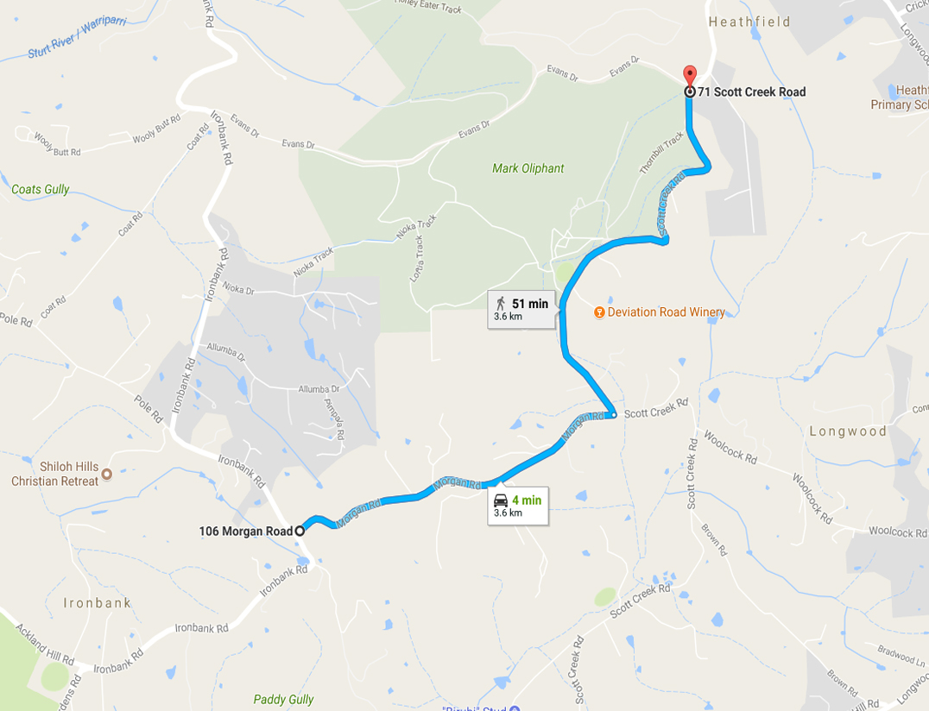

SS10 - Skinny Pole

Road Closed:
Pole Rd

Closure Start:
Learmonth Ct

Closure Finish:
Upper Sturt Rd

Intersections along Stage:
None

Operational: Same as 2021 TS at Bridge, no RSP

THURSDAY 24th NOVEMBER 1:00pm to 4:45pm
https://www.google.com/maps/dir/-35.0354378,138.6758005/-35.0269306,138.6716711/@-35.0290117,138.6706848,16.5z/data=!4m2!4m1!3e0

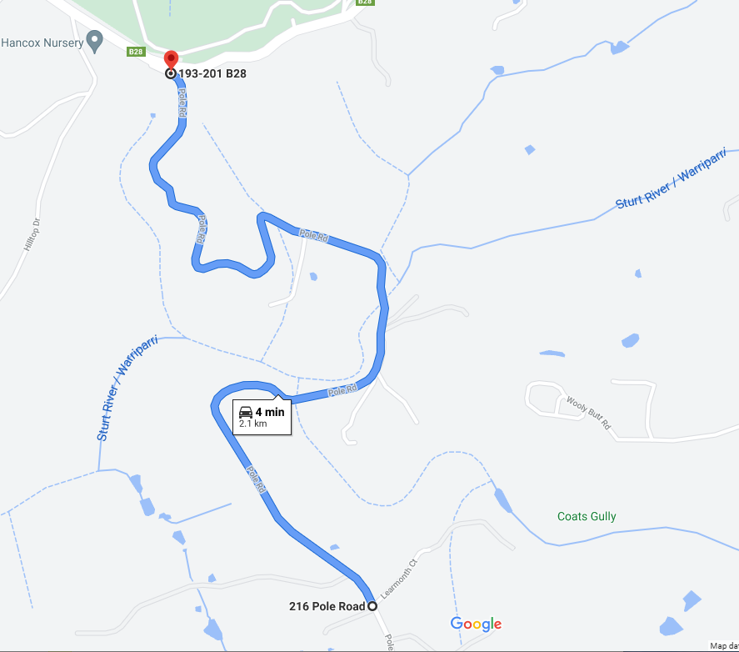

SS11 - Windy Point

Road Closed:
Belair Rd

Closure Start:
Culley Ave

Stage Start: 100m in from Culley Ave.

Closure Finish:
Cornish Ct

Intersections along Stage:
Aerial Rd
Marina Ave
Kalyra Rd

Operational : Same as 2021 RSP @ approx. 1.3

THURSDAY 24TH NOVEMBER 1:10 to 5:00
https://www.google.com/maps/dir/-34.9980944,138.6213104/-34.995727,138.6094687/@-34.9991744,138.6119333,16.5z/data=!4m2!4m1!3e0

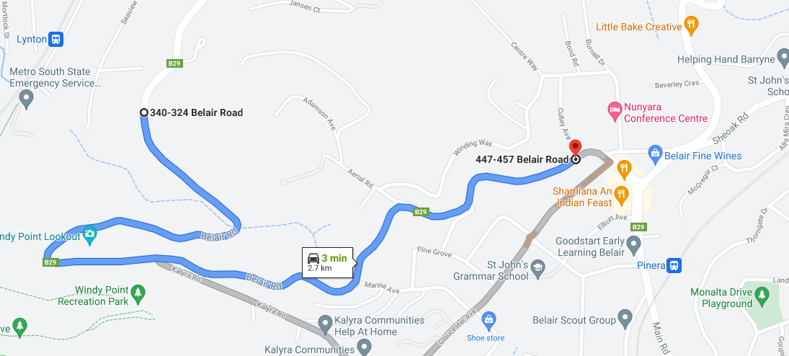

SS12 - Beaumont

Road Closed:
Hayward Drive

Closure Start:
Caithness and Hayward Drive Intersection

Stage Start : as close as practicable to Caithness

Closure Finish:
Centre Track and Hayward Drive Intersection

Intersections along Stage:
None

Operational : Same as 2021
FRIDAY 25th NOVEMBER 8:05am to 1:10pm
.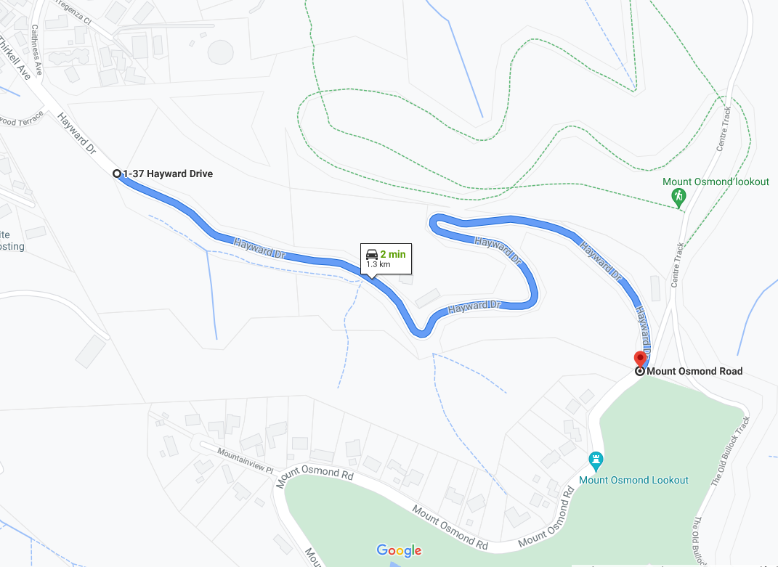

SS13 - Eagle on the Hill

Road Closed:
Old Mt Barker Rd

Closure Start:
Freeway Off Ramp

Closure Finish:
Freeway On Ramp

Intersections along Stage:
None

Operational: TS before tunnel. RSP @2.9 & 3.5 TBC. Use Carpark at approx. 3.7 Measdays lookout. FF at conservation Park entry.

FRIDAY 25th NOVEMBER 8:15am to 1:20pm
https://www.google.com/maps/dir/-34.9675582,138.6687216/-34.979882,138.6867186/@-34.9775735,138.6786805,14.96z/data=!4m2!4m1!3e0

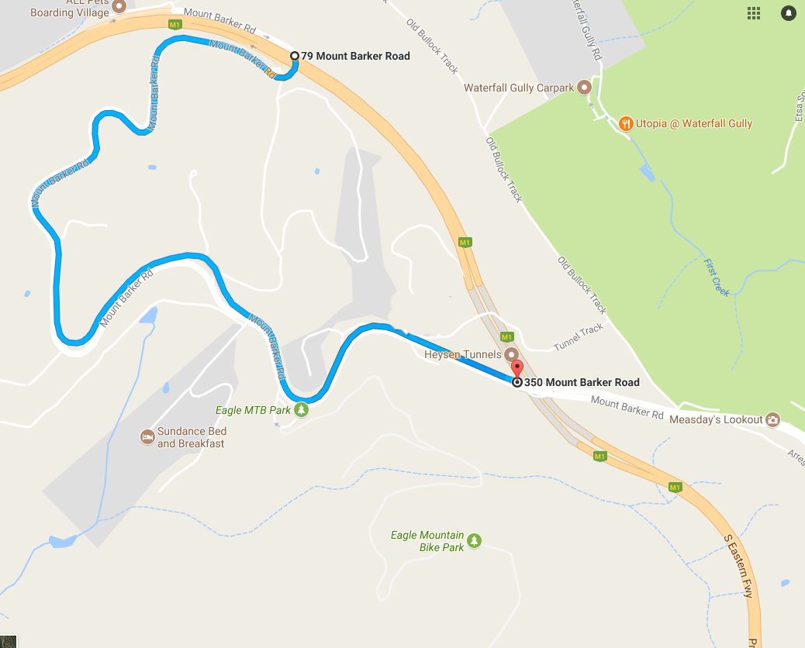

SS14 - Cleland 1

Road Closed:
Summit Rd

Closure Start:
Cleland Wildlife Park entrance and Summit Rd intersection

Closure Finish:
Greenhill Rd / Summit Rd intersection

Intersections along Stage:
Gores Rd
Sprigg Rd

Operational: Start same as 2021, !!C at approx. .5 for RH. FF roughly 34°57.583'S, 138°42.875'E . ‘Open for business’ sign required for Cleland , placed at Summit Rd top near carpark.

FRIDAY 25th NOVEMBER 8:30am to 1:20pm

https://www.google.com/maps/dir/-34.9707484,138.7126602/-34.9580706,138.7159464/@-34.964303,138.7127301,15z/data=!4m2!4m1!3e0
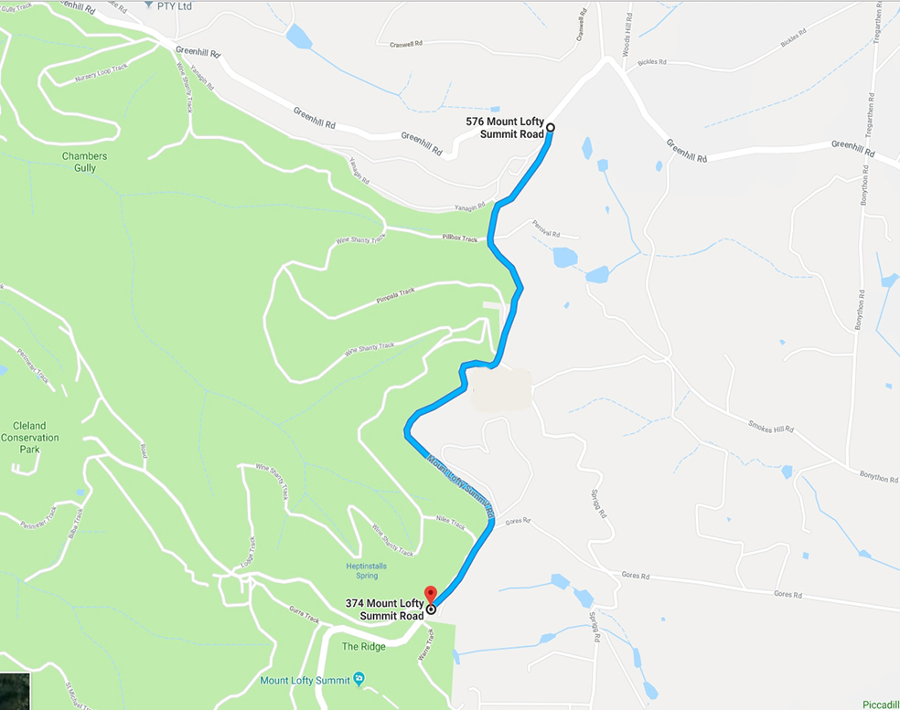

SS15 – Cherryville Plus 1

Road Closed:
Montacute Rd, Marble Hill Rd, Corkscrew Rd, Gorge Rd,

Closure Start:
Lobethal Rd and Marble Hill Rd intersection

Closure Finish:
Prairie Rd/Gorge Rd intersection

Intersections along Stage:
Monomeith Rd
Tembys Rd
Lindner Ave
Wightmans Rd
Pound Rd
Debneys Rd
Moores Rd
Old Cherryville Rd
Cherryville Rd
Narrow Range Rd
Hill Rd
Church Rd
Valley Rd
Gorge Rd
Batchelor Rd

Operational: TS at roughly 34°56.139'S, 138°44.395'E , !C @.30 RGR> 1.30 review RSP. 2021 RSP1 move to 80 sign earlier. RSP2 & RSP3 & RSP 4 remove, RSP 5 keep @ 6.8 RSP 6 keep at approx. 14.8 RSP 7 remove at 15.5. RSP 8 keep at approx 19.1. Move FF to opposite pull out area.

FRIDAY 25th NOVEMBER 9:05am to 4:30pm
https://www.google.com/maps/dir/-34.9340571,138.7354198/-34.8405767,138.8091903/@-34.9484567,138.6919982,13.25z/data=!4m9!4m8!1m5!3m4!1m2!1d138.7466814!2d-34.9276115!3s0x6ab735117401161d:0xeff92f271af00c53!1m0!3e0
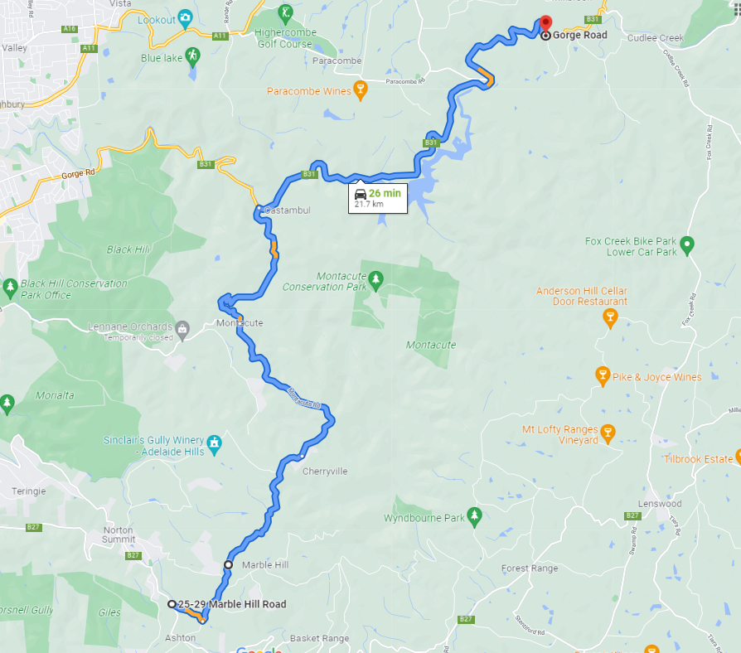

SS16 - Vista 1

Road Closed:
Lower North East Rd

Closure Start:
Range Rd Sth

Stage Start : As close as practicable to Range Rd

Closure Finish:
Perseverance Rd

Intersections along Stage:
None

FRIDAY 25th NOVEMBER 9:50am to 6:55pm
https://www.google.com/maps/dir/-34.8409813,138.7458741/-34.8387613,138.7252049/@-34.8408347,138.7270421,14.75z/data=!4m2!4m1!3e0

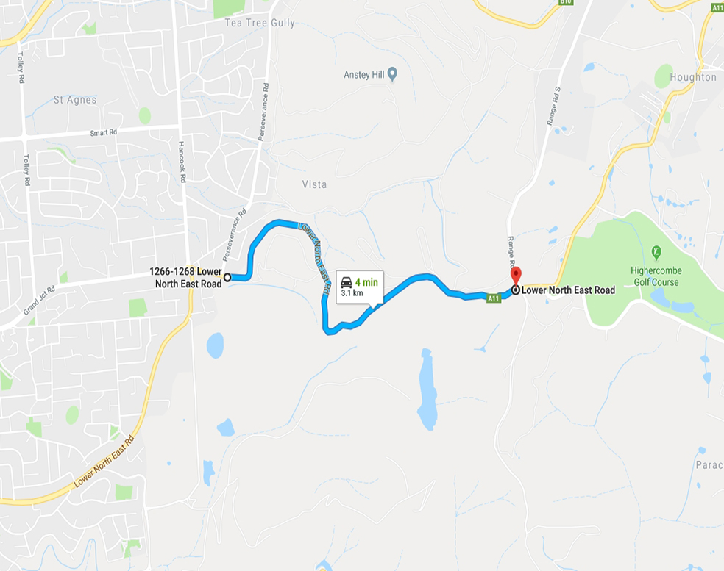

SS17–Norton Summit

Road Closed:
New Norton Summit Rd

Closure Start:
Cnr Coach House Drive and Norton Summit Rd intersection

Closure Finish:
Lobethal Rd and Norton Summit Rd intersection (Scenic Hotel)

Intersections along Stage:
Teringie Drive
Valley Drive
Ridgeland Drive
(all of the above have access and egress)

Operational : As per 2021, include road barriers on Corkscrew Road as per Morialta stage.

FRIDAY 25th NOVEMBER 11:15am to 6:30pm
https://www.google.com/maps/dir/-34.9085578,138.6912406/-34.9197307,138.7222843/@-34.9151488,138.7007182,15.25z/data=!4m14!4m13!1m10!3m4!1m2!1d138.6963875!2d-34.9104023!3s0x6ab0cae866d93769:0x5d6b5833908af044!3m4!1m2!1d138.7046759!2d-34.906448!3s0x6ab0cac7ac3fc10d:0xb6e72c0cece40a4a!1m0!3e0

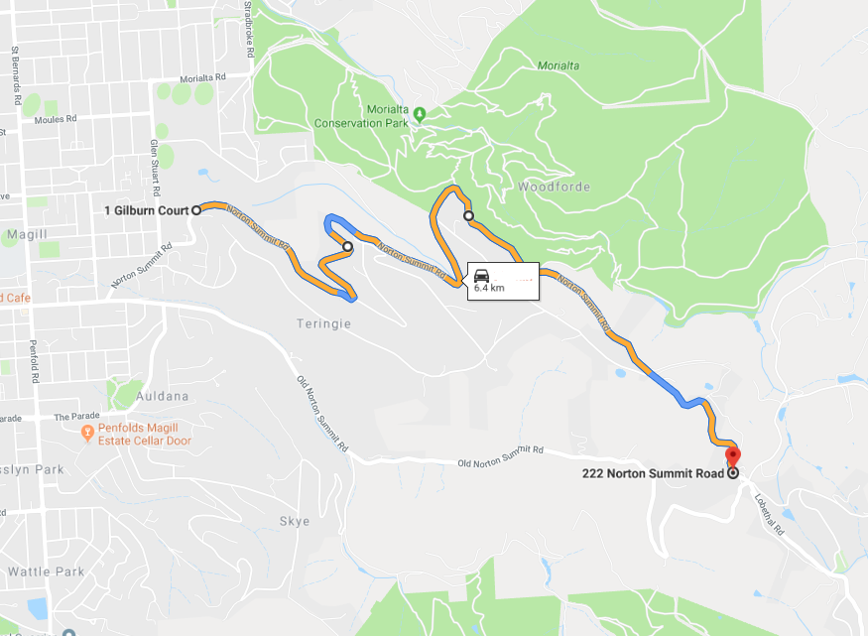

SS18– Cherryville Plus 2

Road Closed:
Montacute Rd, Marble Hill Rd, Corkscrew Rd, Gorge Rd,

Closure Start:
Lobethal Rd/Marble Hill Rd intersection

Closure Finish:
Prairie Rd/Gorge Rd intersection

Intersections along Stage:
Monomeith Rd
Moores Rd
Debnys Rd
Lindner Rd
Pound Rd
Tembys Rd
Wightmans Rd
Old Cherryville Rd
Cherryville Rd
Narrow Range Rd
Hill Rd
Church Rd
Valley Rd
Gorge Rd
Batchelor Rd

Operational: as per Cherryville Plus 1

FRIDAY 25th NOVEMBER 9:05am to 4:30pm
https://www.google.com/maps/dir/-34.9277573,138.7465497/-34.8405767,138.8091903/@-34.8867575,138.7449127,13z/data=!4m2!4m1!3e0

SS19 - Stafford Hillclimb 2

Road Closed:
Fox Creek Rd
Mawson Trail
Staffords Rd

Closure Start:
Adjacent Fox Creek Mountain Bike Park Carpark - Fox Creek Rd
Stage Start : As close to Mtn Bike Park carpark as possible.
Closure Finish:
Staffords Rd approximately 150m from Mawson Trail

Intersections along Stage:
Croft Rd, Coldstore Rd

Operational: As per Stafford Hillclimb 1

FRIDAY 25th NOVEMBER 12:05pm to 5:15pm
https://www.google.com/maps/dir/-34.8774356,138.8387514/-34.8942201,138.8404196/@-34.8870647,138.8341013,15.25z/data=!4m2!4m1!3e0

SS20 – Cleland 2

Road Closed:
Summit Rd

Closure Start:
Cleland Wildlife Park entrance and Summit Rd intersection

Closure Finish:
Greenhill Rd / Summit Rd intersection

Intersections along Stage:
Gores Rd
Sprigg Rd

Operational: As per Cleland 1. Note 30 min gap in between running of Cleland 1 and 2

FRIDAY 25th NOVEMBER 1:50pm till 6:30pm
https://www.google.com/maps/dir/-34.9707484,138.7126602/-34.9580706,138.7159464/@-34.964303,138.7127301,15z/data=!4m2!4m1!3e0

SS21 – Teringie

Road Closed:
New Norton Summit Rd

Closure Start:
Lobethal Rd and Norton Summit Rd intersection (Scenic Hotel)

Closure Finish:
Cnr Coach House Drive and Norton Summit Rd intersection

Intersections along Stage:
Teringie Drive
Valley Drive
Ridgeland Drive
(all of the above have access and egress)

Operational : As per 2021 RSP @ approx. 1.1 & 1.6

FRIDAY 25th NOVEMBER 11:15am to 6:30pm
https://www.google.com/maps/dir/-34.9085578,138.6912406/-34.9197307,138.7222843/@-34.9151488,138.7007182,15.25z/data=!4m14!4m13!1m10!3m4!1m2!1d138.6963875!2d-34.9104023!3s0x6ab0cae866d93769:0x5d6b5833908af044!3m4!1m2!1d138.7046759!2d-34.906448!3s0x6ab0cac7ac3fc10d:0xb6e72c0cece40a4a!1m0!3e0

SS22 – Anstey Hill

Road Closed:
Lower North East Rd

Closure Start:
Perseverance Rd

Closure Finish:
Range Rd South

Intersections along Stage:
None

FRIDAY 25th NOVEMBER 9:50am to 6:55pm
https://www.google.com/maps/dir/-34.8409813,138.7458741/-34.8387613,138.7252049/@-34.8408347,138.7270421,14.75z/data=!4m2!4m1!3e0

SS23 - Hermitage

Road Closed:
One Tree Hill Rd, Seaview Rd, Range Rd

Closure Start:
Approx Verral Rd and Range Rd Intersection.

Stage Start : 150m North of Verral Rd.

Closure Finish:
Hannaford Hump intersection with One Tree Hill Rd

Intersections along Stage:
Hannaford Hump Rd, Seaview Rd, One Tree Hill Rd, Range Rd

Operational: TS at 34°47.132'S, 138°45.520'E: RSP @ 1.18 Start RSP before Green sign. FF 200m before Hannaford Hump Rd. SP 34°45.458'S, 138°45.117'E

SATURDAY 26th NOVEMBER 8:20am to 1:25pm
https://www.google.com/maps/dir/-34.7911077,138.760931/-34.7575382,138.7692859/@-34.7619203,138.7519791,13.5z/data=!4m2!4m1!3e0

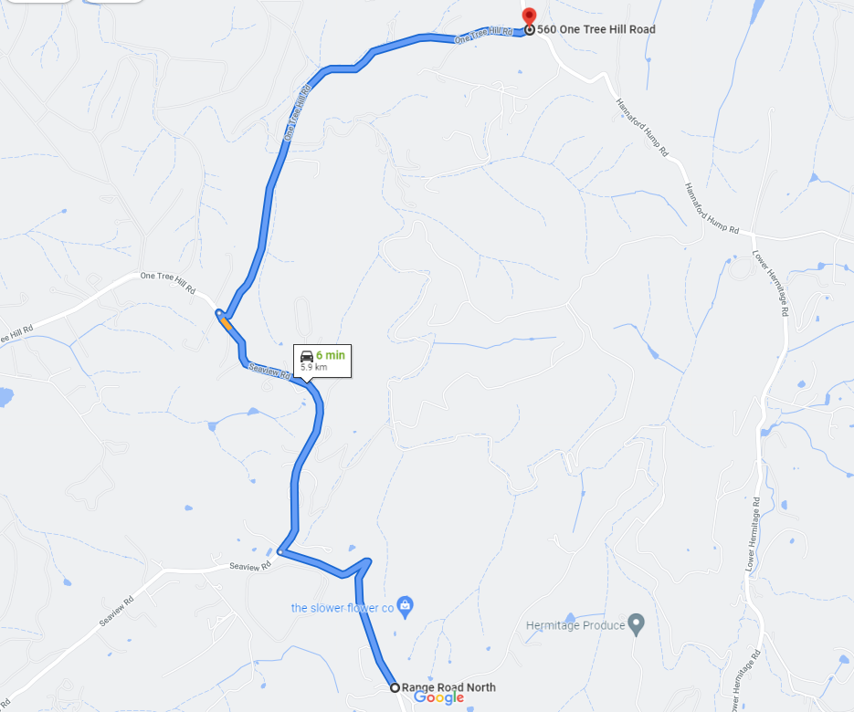

SS24 – Chain of Ponds

Road Closed:
North East Rd

Closure Start:
Fiddlers Hill Rd

Closure Finish:
Gorge Rd intersection

Intersections along Stage:
Millbrook Road
Kersbrook Rd
Tippet Rd
North East Rd/Tippet Rd

Operational : Same as 2021 1x RSP. Erect advanced notice Gorge Detour signs prior to Gorge Rd on North East Rd.

SATURDAY 26th NOVEMBER 8:45am to 4:45pm
https://www.google.com/maps/dir/-34.8190116,138.7979234/-34.8351941,138.8218733/@-34.8283249,138.8110246,14.75z/data=!4m2!4m1!3e0

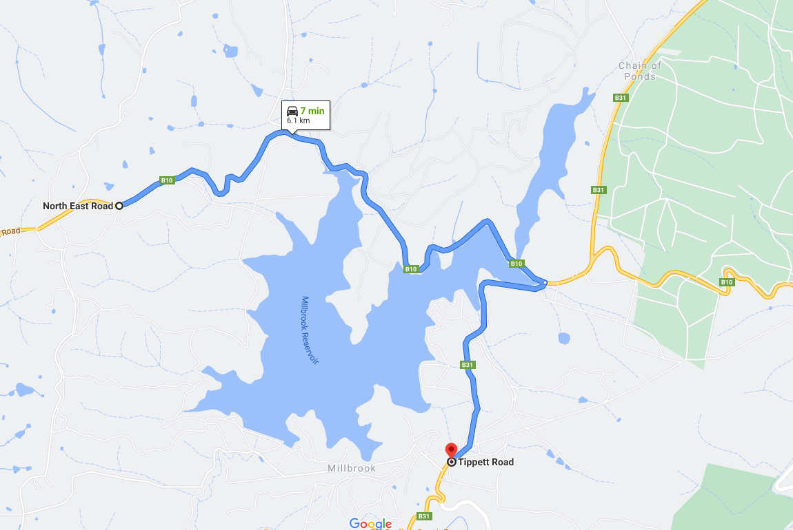

SS25 – Kangaroo Creek (TO BE DOWNGRADED PRE EVENT- NOT RUNNING )

Road Closed:
Gorge Rd

Closure Start:
Torrens Hill Rd

Closure Finish:
Batchelors Rd

Intersections along Stage:
None

Operational: TS250m West of Torrens Hill Rd. FF on Bridge. SP at Old House. RSP @ 3 & 3.6 approximately

SATURDAY 26th NOVEMBER 9:00am to 2:00pm

https://www.google.com/maps/dir/-34.8494395,138.7977303/-34.8683498,138.7562741/@-34.8585255,138.7699856,15z/data=!4m2!4m1!3e0

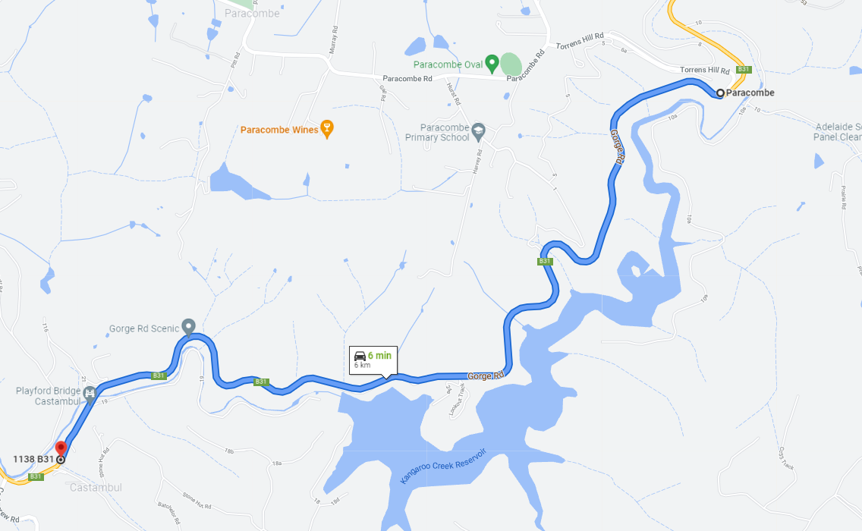

SS26 Old Norton Summit 1

Road Closed:
Old Norton Summit Rd

Closure Start:
Horsnells Gully Rd

Closure Finish:
Lobethal Rd

Intersections along Stage:
None

Operational: TS @ 34°55.300'S, 138°41.960'E. Tyre Bundle at stobie 1.45. FF @ Norton Summit Sign.

SATURDAY 26th NOVEMBER 10:00am to 5:55pm
https://www.google.com/maps/dir/-34.9213087,138.6981012/-34.9229842,138.7243923/@-34.9232687,138.707953,15.75z/data=!4m2!4m1!3e0
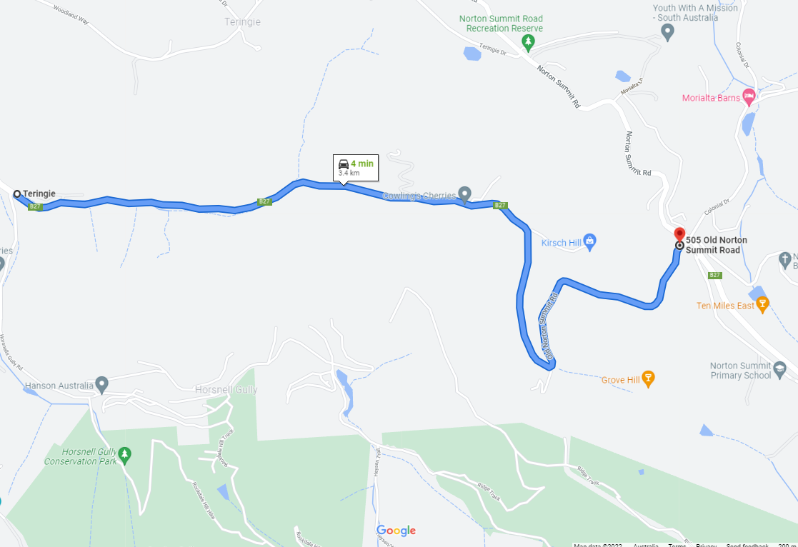

SS27– Forest Range

Roads Closed:
Lobethal Rd

Closure Start:
Cnr Bartley Street and Old Princes Highway Nairne
Closure Finish:
Cnr Powell Rd and Old Princess Highway Dawesley

Intersections along Stage:
Fern Glen Rd
Steer Rd
Mawson Rd
Deviation Rd
Collins Rd
Norton Rd

Operational: TS @ roughly 34°56.616'S, 138°46.278'E, C! at 2.6 , 3.30 RSP end at armco. 4.20 FF. 4.6 SP

SATURDAY NOVEMBER 26th 9 11:15am to 4:20pm
https://www.google.com/maps/dir/-34.9437212,138.7705757/-34.9283841,138.8065405/@-34.9372424,138.7782306,14.96z/data=!4m2!4m1!3e0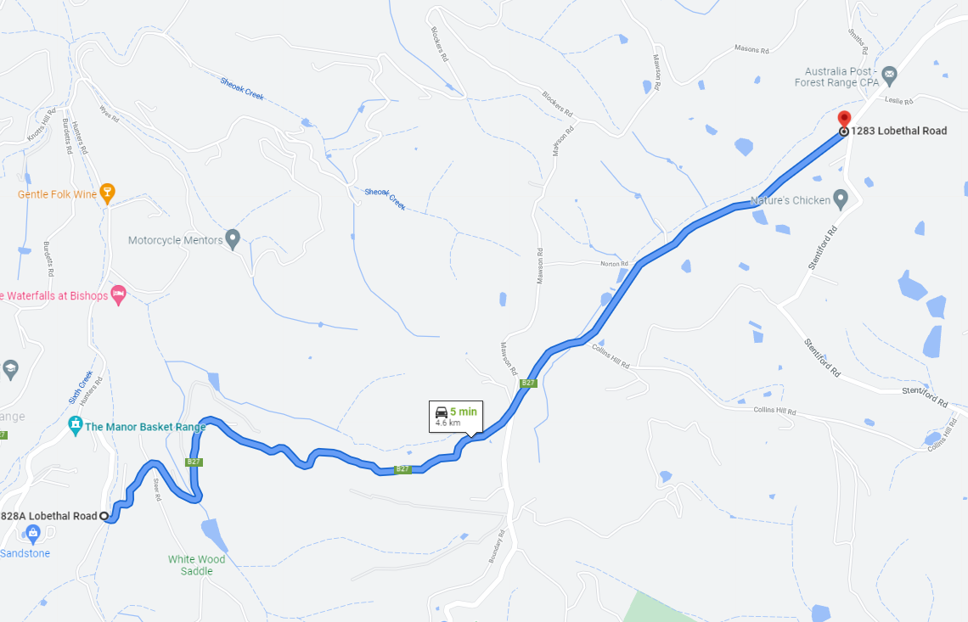

SS28 Millbrook
Road Closed:
North East Rd

Closure Start:
Fiddlers Hill Rd

Closure Finish:
Gorge Rd intersection

Intersections along Stage:
Millbrook Road
Kersbrook Rd
Tippet Rd
North East Rd/Tippet Rd

Operational: TS at Sunninghill Rd. .75 !C . FF@65 sign roughly 34°49.108'S, 138°47.960'E SP at Fiddlers Hill Rd

SATURDAY 26th NOVEMBER 8:45am to 4:45pm
https://www.google.com/maps/dir/-34.8363563,138.8214533/-34.8188512,138.7952018/@-34.8237916,138.7920781,14.5z/data=!4m2!4m1!3e0
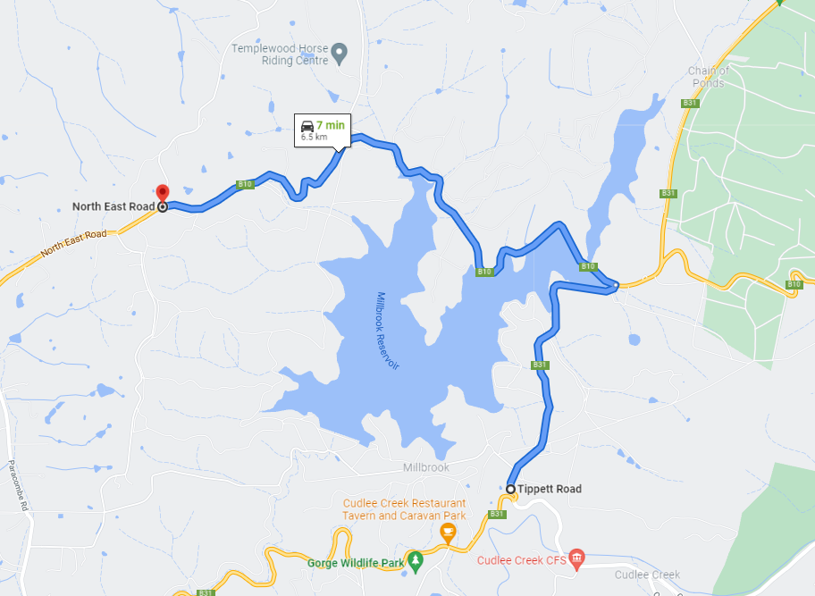

SS29 Vista 2

Road Closed:
Lower North East Rd

Closure Start:
Range Rd Sth

Stage Start : As close as practicable to Range Rd

Closure Finish:
Perseverance Rd

Intersections along Stage:
None

SATURDAY 26th NOVEMBER 12:00pm to 5:00pm
https://www.google.com/maps/dir/-34.8409813,138.7458741/-34.8387613,138.7252049/@-34.8408347,138.7270421,14.75z/data=!4m2!4m1!3e0

SS30 Old Norton Summit 2

Road Closed:
Old Norton Summit Rd

Closure Start:
Horsnells Gully Rd

Closure Finish:
Lobethal Rd

Intersections along Stage:
None

SATURDAY 26th NOVEMBER 10:00am to 5:55pm
https://www.google.com/maps/dir/-34.9213087,138.6981012/-34.9229842,138.7243923/@-34.9232687,138.707953,15.75z/data=!4m2!4m1!3e0

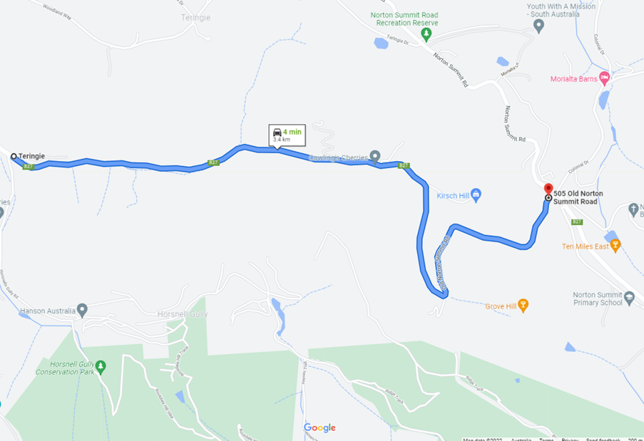

SS31 - Leawood Gardens

Road Closed:
Old Mt Barker Rd

Closure Start:
Freeway Off Ramp

Closure Finish:
Freeway On Ramp

Intersections along Stage:
None

Operational : RSPs x 1

SATURDAY 26th 1:40pm till 6:30pm
https://www.google.com/maps/dir/-34.9818985,138.6876713/-34.9680084,138.6703764/@-34.9739867,138.6672221,15z/data=!4m2!4m1!3e0

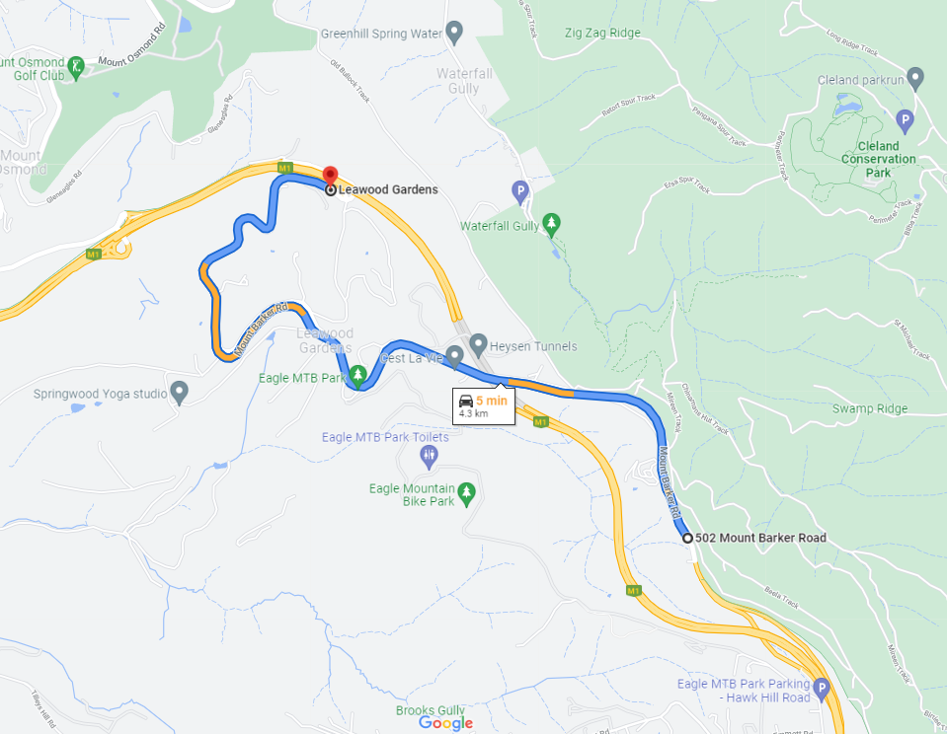

SS32– Vic Park

Road Closed:
Wakefield Road

Closure Start:
Brittania Roundabout

Closure Finish:
East Tce

Intersections along Stage:
None.

Operational : Uses Victoria Park Circuit and Wakefield Rd.

SATURDAY 26th NOVEMBER 3:00pm – 8:00pm TBC

SS33– Mt Lofty

Road Closed:
Greenhill Rd and Summit Rd

Closure Start:
661 Greenhill Rd

Closure Finish:
Summit Rd and Cleland Wildlife Park entrance intersection. Cleland has access.

Intersections along Stage:
Yarrabee Rd, Yanagin Rd, Greenhill Rd, Sprigg Rd, Gores Rd

Operational : Same RSP as 2021

SUNDAY 27th NOVEMBER 8:05 to 1:10pm
https://www.google.com/maps/dir/-34.9420849,138.6718371/-34.9708764,138.7125435/@-34.9550807,138.6819732,14.75z/data=!4m2!4m1!3e0

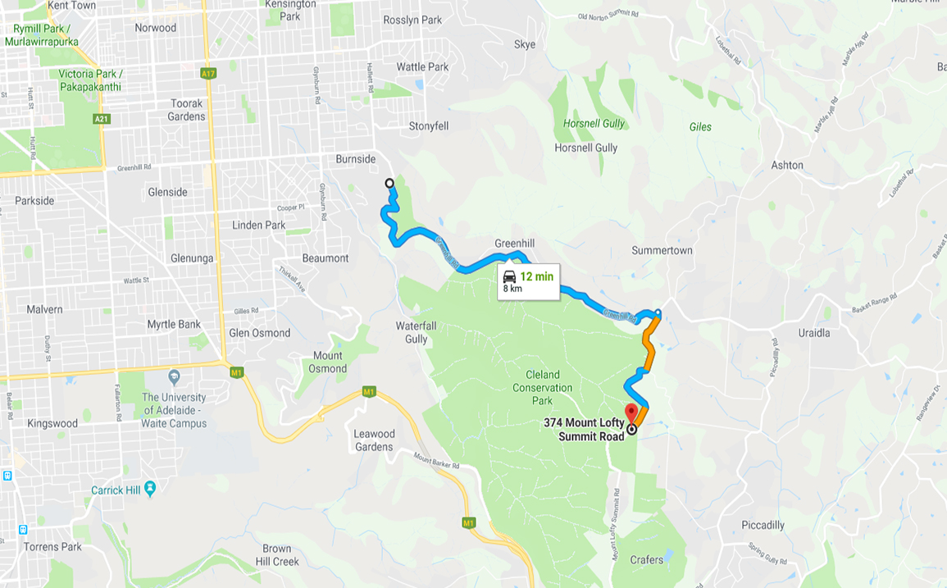

SS34– Mylor

Road Closed:
Forbes Rd, Aldgate Valley Rd

Closure Start:
Emery Rd / Forbes Rd
Stage Start : 250m East of Emery Rd

Closure Finish:
350m West of Stock Rd

Intersections along Stage:
Williams Rd, Shanks Rd, Blackwood Ln, Kiley Rd, Stevens Lane, Mi Mi Rd, Nation Ridge Rd

Operational: RSP before House (#104 Aldgate Valley Road).

SUNDAY 27^{h} NOVEMBER 8:30am to 12:40pm
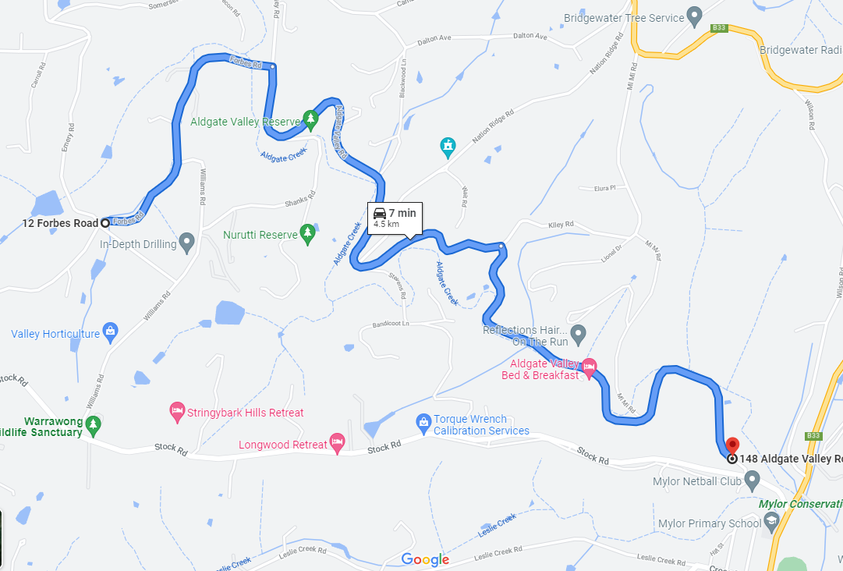

SS35 - Strath Hill

Route Summary
Start:
Cosgrove Road (Doc Creek Stop Point)

Finish:
Strathalbyn Road Cnr Waterman Road (Waterman Rd residents will have access)

Stage Road(s)
Strathalbyn Road

Operational: Special access for residents in window RSPx2

SATURDAY 27th NOVEMBER 9:20 to 4:45pm
https://www.google.com/maps/dir/-35.1805594,138.8412909/-35.2358031,138.887806/@-35.1829505,138.8421407,16z/data=!4m2!4m1!3e0

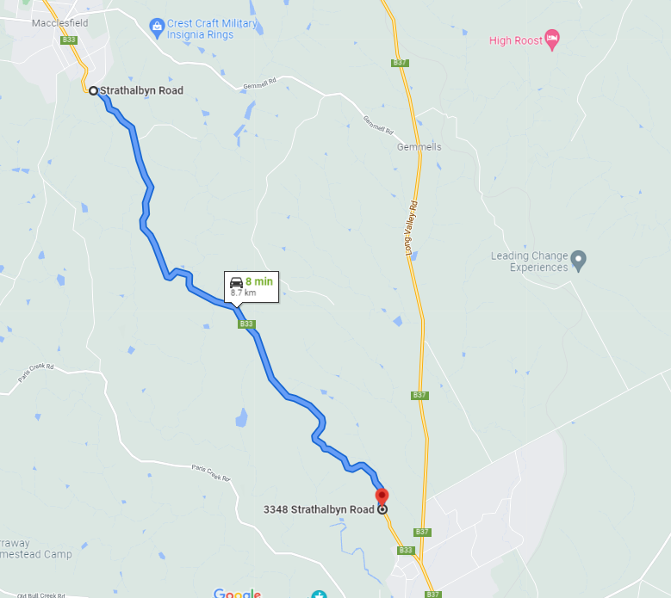

SS36– Bull Creek

Road Closed:
Bull Creek Road

Closure Start:
Henry Martin Rd
Stage Start : 250m North of Henry Martin Rd

Closure Finish:
600m South of Paris Creek Rd

Intersections along Stage:
McHarg Creek Rd
Spring Gully Rd
Bald Hill Rd
Usher Rd
Carrol Rise
Nicol Rd
Phillips Hill Rd
Reid Rd

SUNDAY 27th NOVEMBER 10:00am to 3:00pm
https://www.google.com/maps/dir/-35.2783177,138.7699591/-35.1983062,138.7715161/@-35.235062,138.7303927,13.21z/data=!4m2!4m1!3e0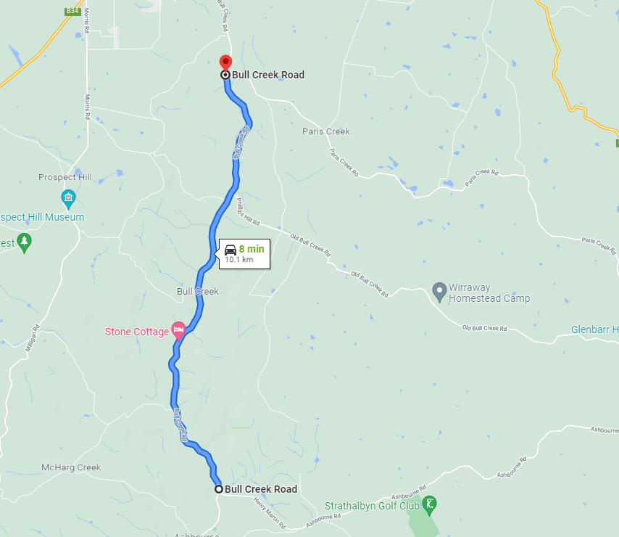

SS38– Strath Town Stage

Road Closed:
Commercial Rd
Albyn Terrace
Catherine Street
Donald Street
Rankine Street
Sunter Street
Swale Street High Street
Chapel Street

Closure Start:
Commercial Rd/Colman Terrace

Closure Finish:
Chapel Street / Murray Street

Intersections along Stage:
Several

SUNDAY 27th NOVEMBER 11:30am to 4:40pm
https://www.google.com/maps/dir/-35.257574,138.889522/-35.2555389,138.8947777/@-35.2559518,138.8928973,18z/data=!4m19!4m18!1m15!3m4!1m2!1d138.8915771!2d-35.2593832!3s0x6ab6d8085c843d61:0x13033654492a66f0!3m4!1m2!1d138.8918517!2d-35.2582215!3s0x6ab6d80826fed0e7:0xa4766cfbd86e89c0!3m4!1m2!1d138.8926546!2d-35.2559819!3s0x6ab727f655073d27:0x1303365449200fd0!1m0!3e0
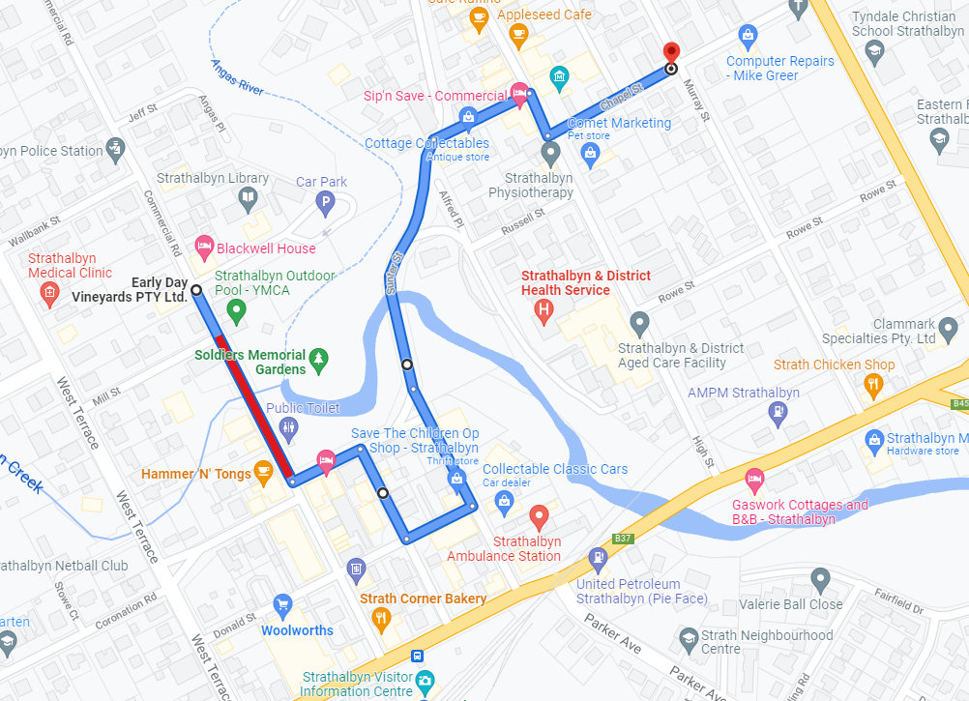

SS38 - Doctors Creek
Route Summary
Start:
Strathalbyn Road after Waterman Road (Waterman Rd residents will have access).

Finish:
Cosgrove Rd

Stage Road(s)
Strathalbyn Road

Intersections
Nyoka Rd

Operational: RSPs x 3?

SUNDAY 27th NOVEMBER 9:20 to 4:45pm

https://www.google.com/maps/dir/-35.2372062,138.8889428/-35.1874277,138.847982/@-35.2203519,138.8289688,13.25z/data=!4m2!4m1!3e0
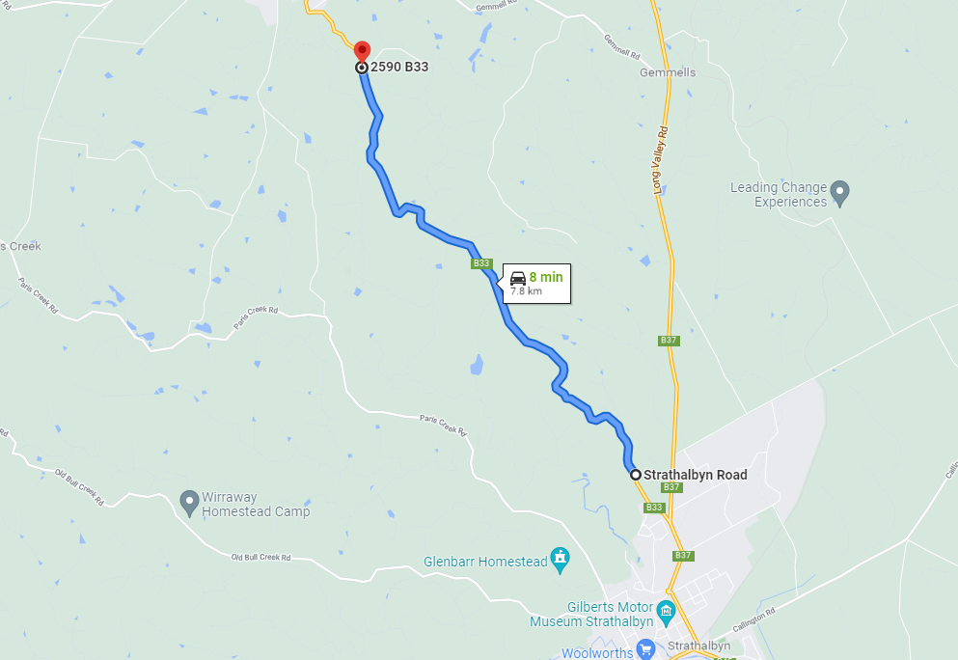

SS39 – Aldgate Valley

Road Closed:
Aldgate Valley Rd, Nation Ridge Rd

Closure Start:
Stock Rd / Aldgate Valley Rd
Stage Start : As close as possible to Stock Rd

Closure Finish:
Wait Rd/ Nation Ridge Rd intersection

Intersections along Stage:
Mi Mi Rd
Kiley Rd
Nation Ridge Rd

Operational : Special signage before Nation Ridge Rd

SUNDAY 27th NOVEMBER 1:10pm to 5:45pm

https://www.google.com/maps/dir/-35.0370824,138.7582709/-35.029545,138.7473105/@-35.0356065,138.7511255,15z/data=!4m2!4m1!3e0
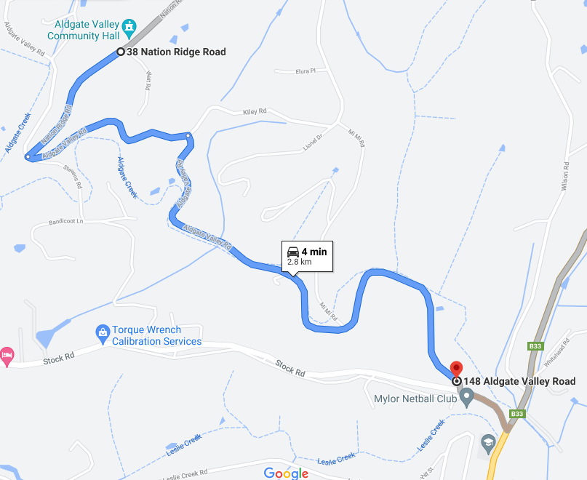

SS40 – Sturt Valley

Roads Closed:
Sturt Valley Rd

Closure Start:
274 Sturt Valley Rd

Closure Finish:
Sturt Valley Rd & Longwood Rd intersection

Intersections along Stage:
Wychwood Grove
Elmstead Drive
Ironbank Rd
Manoah Drive
Whitewood Drive
Heather Rd

SUNDAY 27^{h} NOVEMBER 12:50pm to 5:55pm
https://www.google.com/maps/dir/-35.0237723,138.6794755/-35.0122772,138.7012596/@-35.0179568,138.6872187,16z/data=!4m2!4m1!3e0

